# SQL Injection Vulnerability in Electronix-online-shopping-site
The SQL injection vulnerability exists in `Electronix-online-shopping-site-master/admin_area/logincheck.php`, where the following code is present:

```php
$uid=$_POST["text1"];
$pwd=$_POST["password1"];

$qry="select * from ad_log where aname='$uid' and apwd='$pwd'";
```

Along with the parameter check logic:
```php
if(!isset($_POST["text1"]))
{
header("location:login.html");
}
```

This code **directly concatenates** the user inputs `$_POST["text1"]` and `$_POST["password1"]` into the SQL statement (`"select * from ad_log where aname='$uid' and apwd='$pwd'"`) without any escaping or preprocessing. Malicious users can construct special inputs (e.g., `admin' OR 1=1 --`) to tamper with the SQL logic, thereby bypassing login verification, stealing data, or even modifying the database.

## Vulnerability Demonstration
1. Access the backend login page via `http://shang/admin_area/login.html`
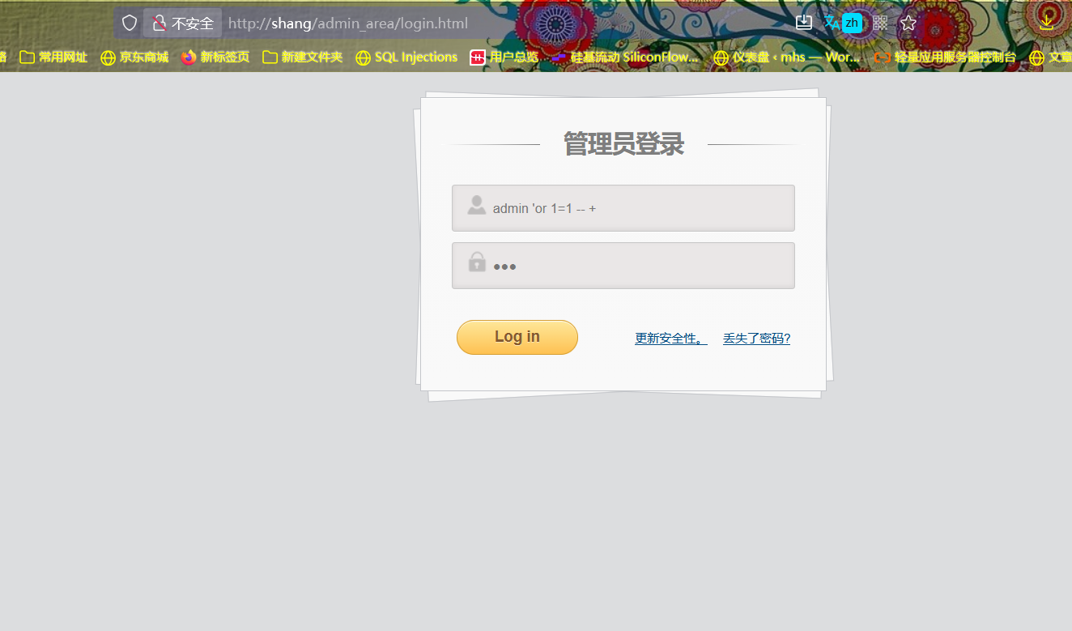

2. In the "Username" field, enter `’or 1=1 -- +` (keep the "Password" field as any random input), then submit. You will **directly access the backend** without valid credentials.
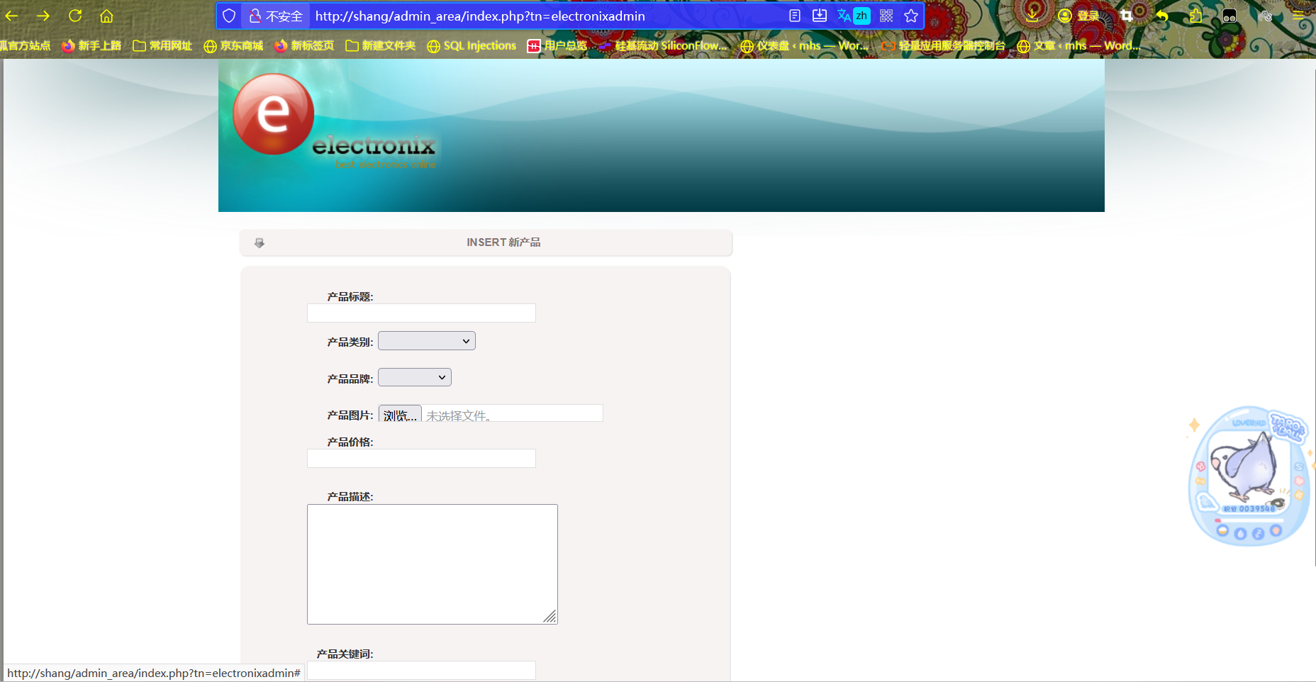

## Project Setup and Vulnerability Reproduction
### Download Link
https://github.com/Jagdeep-Sing/Electronix-online-shopping-site

### General Directory Structure
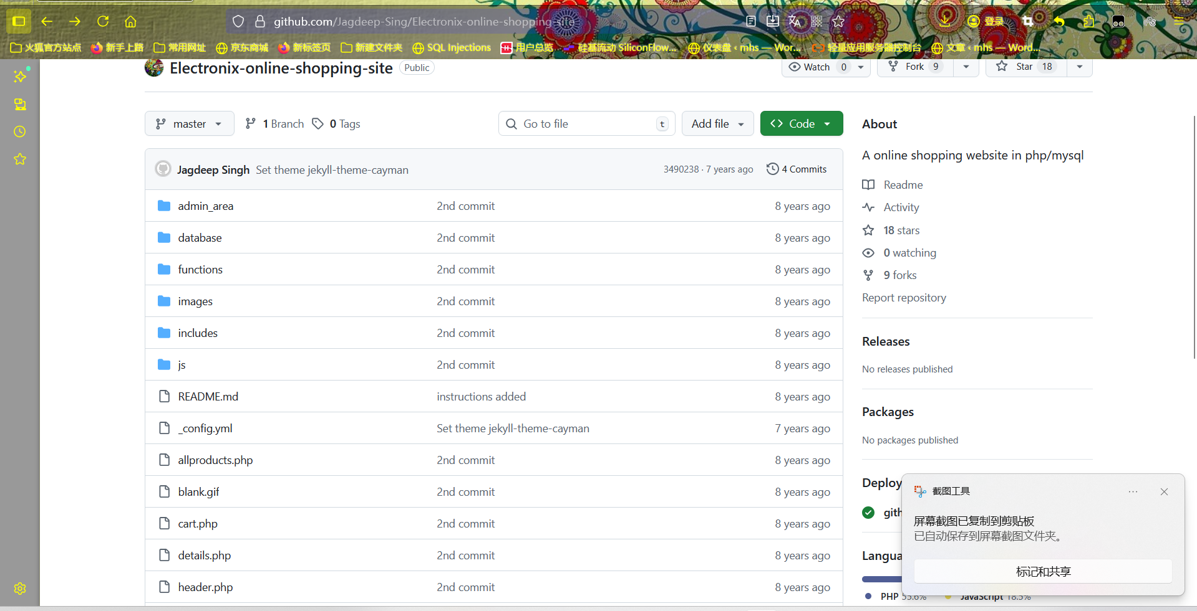
### Setup Steps
1. Open phpStudy, locate the root directory, and place the downloaded project files into it.
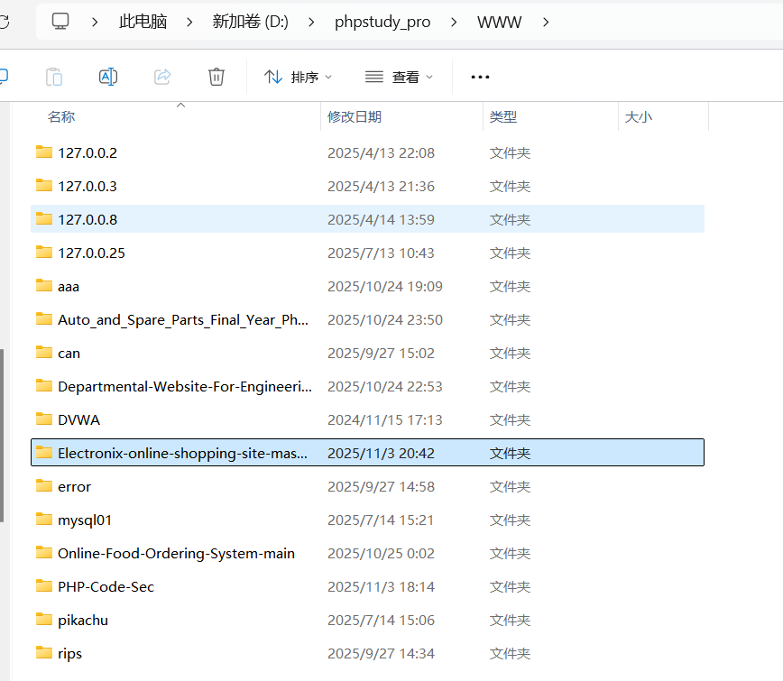
2. In phpStudy, create a database named `electronix`, then import the `db.sql` file (from the project’s `database` directory) into this database.

3. Create a new website in phpStudy:
- Set the "Root Directory" to the project folder under `WWW` (e.g., `D:/phpstudy_pro/WWW/Electronix-online-shopping-site-master`).
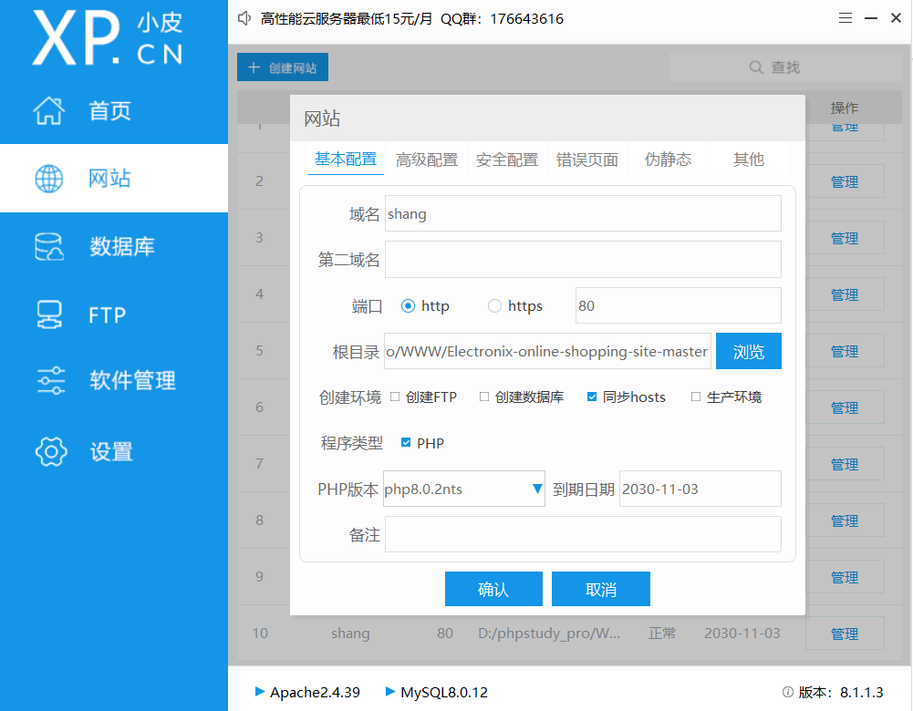

4. Modify the database configuration in the following files to match your local database settings (e.g., username, password):
- `db.php`
- `functions.php`
- `admin_area\logincheck.php`
- `admin_area\includes\db.php`

Example of modified configuration:
```php
<?php
$con = mysqli_connect (hostname: "localhost" , username: "eee", password: "123456" , database: "electronix");
if(mysqli_connect_errno()){
echo"Failed to connect:". mysqli_connect_error();
})
```

5. Start the Apache and MySQL services in phpStudy, then access the website via the configured domain (e.g., `http://shang`).

## Normal Function Demonstration
- **Valid Scenario**: Entering an incorrect username or password will be blocked, with the prompt: `Email or password is incorrect!`
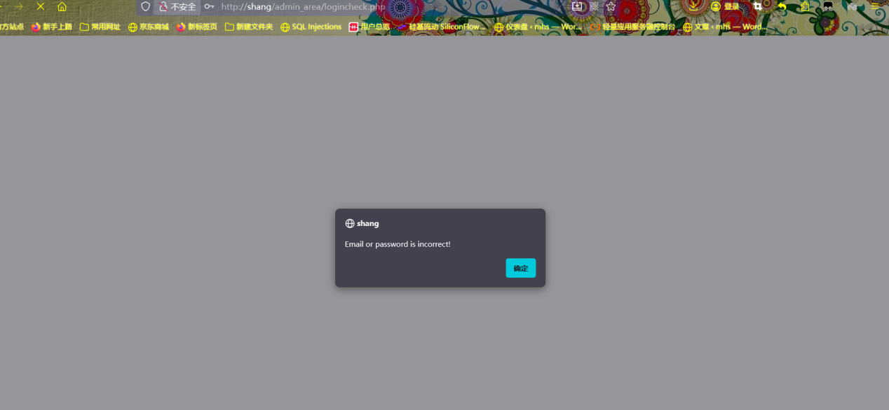

- **Vulnerable Scenario**: Enter `’or 1=1 -- +` in the "Username" field and any random password. You will **directly access the backend** (bypassing login verification).

